DIRECTIONS TO THE BARATARIA UNIT, COQUILLE TRAIL
JEAN LAFITTE NATIONAL HISTORIC PARK & PRESERVE
HOW TO GET THERE: This is a busy map, but the easiest way to get there is to go south on Barataria Boulevard (LA 45) from the Westbank Expressway (U.S. 90) all the way to the park (it will be obvious when you enter as the road passes through the levee). When you get on Barataria Expressway, stay in the far-right lane. The four lanes eventually becomes a two lane, so you will know you are on the right path. The second parking lot on the right is for Coquille Trail (just a mile or so into the park).
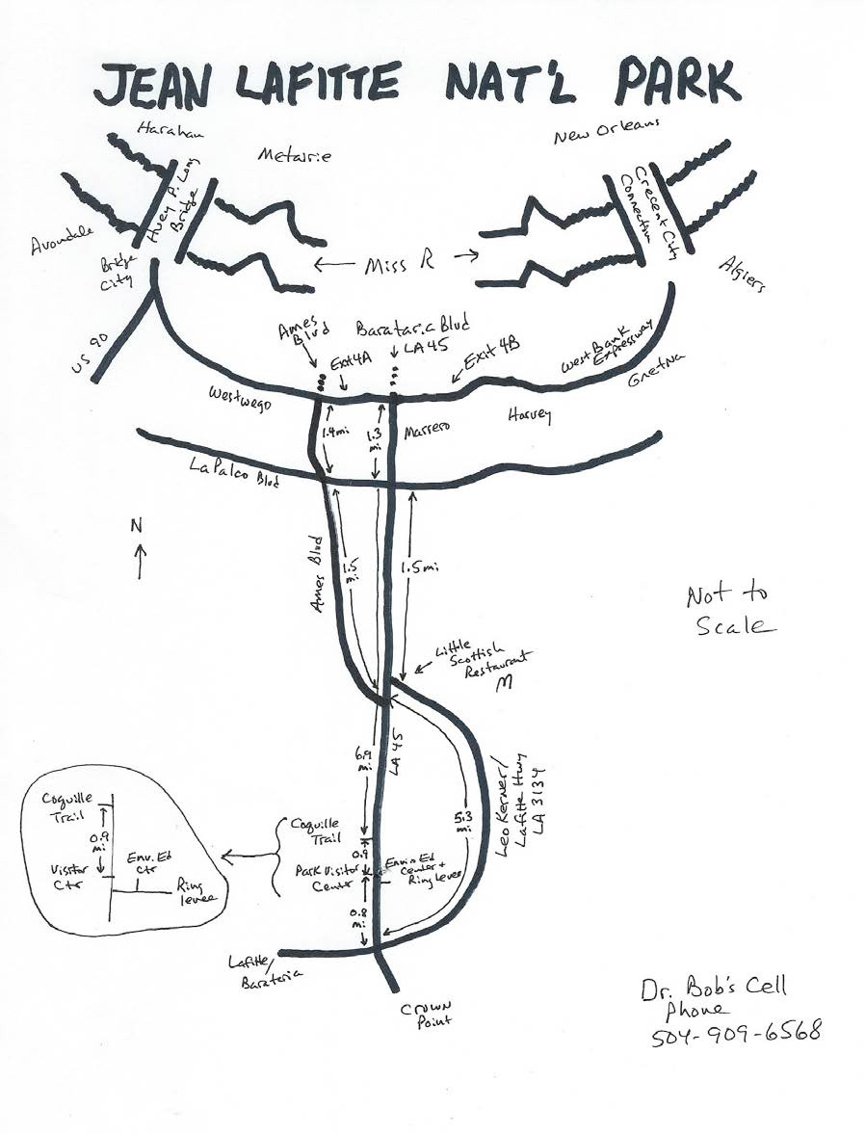
NOTE: Avoid turning left off Barataria Blvd. onto Leo Kerner/Lafitte Highway, as it is farther – but if that is what you normally do, then do it. If you get lost, call DR. BOB at 504-909-6568. We gather at the parking lot gate at dusk.
Use this pin on google maps: https://goo.gl/maps/vJ1LPmJfvnu

WHERE TO PARK: Since the gates are locked at 5 pm, you must park on the side of LA 45 away from the entrance – either side of the highway. BE VERY CAREFUL – CARS SPEED PAST!!!

See you there!

